Health is wealth

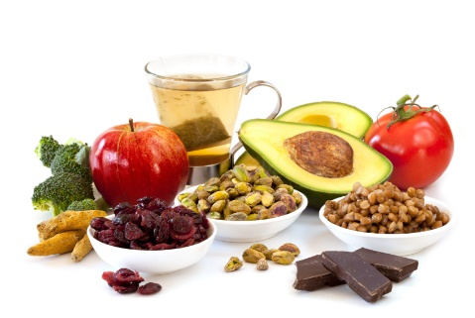

The meaning of health has evolved over time. In keeping with the [biomedical](https://en.wikipedia.org/wiki/Biomedical_model) perspective, early definitions of health focused on the theme of the body's ability to function; health was seen as a state of normal function that could be disrupted from time to time by [disease](https://en.wikipedia.org/wiki/Disease). An example of such a definition of health is: "a state characterized by anatomic, physiologic, and psychological integrity; ability to perform personally valued family, work, and community roles; ability to deal with [physical](https://en.wikipedia.org/wiki/Human_body), [biological](https://en.wikipedia.org/wiki/Biological), [psychological](https://en.wikipedia.org/wiki/Psychology), and [social stress](https://en.wikipedia.org/wiki/Social_stress)".Then, in 1948, in a radical departure from previous definitions, the [World Health Organization](https://en.wikipedia.org/wiki/World_Health_Organization) (WHO) proposed a definition that aimed higher, linking health to [well-being](https://en.wikipedia.org/wiki/Well-being), in terms of "physical, mental, and social well-being, and not merely the absence of disease and infirmity". Although this definition was welcomed by some as being innovative, it was also criticized for being vague and excessively broad and was not construed as measurable. For a long time, it was set aside as an impractical ideal, with most discussions of health returning to the practicality of the biomedical model.

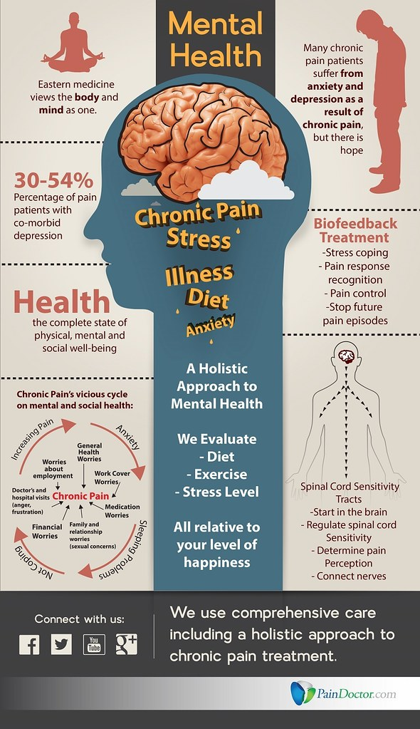

[This Photo](https://www.flickr.com/photos/pain-pix/18338982104) by Unknown Author is licensed under [CC BY](https://creativecommons.org/licenses/by/3.0/)

Just as there was a shift from viewing disease as a state to thinking of it as a process, the same shift happened in definitions of health.   
 Again, the WHO played a leading role when it fostered the development of the health promotion movement in the 1980s. This brought in a new conception of health, not as a state, but in dynamic terms of resiliency, in other words, as "a resource for living". In 1984, WHO revised the definition of health defined it as "the extent to which an individual or group is able to realize aspirations and satisfy needs and to change or cope with the environment. Health is a resource for everyday life, not the objective of living; it is a positive concept, emphasizing social and personal resources, as well as physical capacities." Thus, health referred to the ability to maintain [homeostasis](https://en.wikipedia.org/wiki/Homeostasis) and recover from adverse events. Mental, intellectual, emotional and social health referred to a person's ability to handle stress, to acquire skills, to maintain relationships, all of which form resources for resiliency and [independent living](https://en.wikipedia.org/wiki/Independent_living). This opens up many possibilities for health to be taught, strengthened and learned.

Good health

exercise

nutrition

](https://en.wikipedia.org/wiki/File:Overweight_or_obese_population_OECD_2010.png)

Percentage of overweight or obese population in 2010, Data source: OECD's

](https://en.wikipedia.org/wiki/File:Obese_population_OECD_2010.png)

Percentage of obese population in 2010, Data source: OECD's

An important way to maintain one's personal health is to have a healthy diet. A healthy diet includes a variety of plant-based and animal-based foods that provide [nutrients](https://en.wikipedia.org/wiki/Nutrients) to the body. Such nutrients provide the body with energy and keep it running. Nutrients help build and strengthen bones, muscles, and tendons and also regulate body processes (i.e., [blood pressure](https://en.wikipedia.org/wiki/Blood_pressure)). Water is essential for growth, reproduction and good health. [Macronutrients](https://en.wikipedia.org/wiki/Macronutrients) are consumed in relatively large quantities and include proteins, carbohydrates, and fats and fatty acids. Micronutrients – vitamins and minerals – are consumed in relatively smaller quantities, but are essential to body processes.[[41]](https://en.wikipedia.org/wiki/Health#cite_note-41) The [food guide pyramid](https://en.wikipedia.org/wiki/Food_guide_pyramid) is a pyramid-shaped guide of healthy foods divided into sections. Each section shows the recommended intake for each food group (i.e., protein, fat, carbohydrates and sugars). Making healthy food choices can lower one's risk of heart disease and the risk of developing some types of [cancer](https://en.wikipedia.org/wiki/Cancer), and can help one maintain their weight within a healthy range.[[42]](https://en.wikipedia.org/wiki/Health#cite_note-42)

The [Mediterranean diet](https://en.wikipedia.org/wiki/Mediterranean_diet) is commonly associated with health-promoting effects. This is sometimes attributed to the inclusion of bioactive compounds such as [phenolic compounds](https://en.wikipedia.org/wiki/Phenolic_compound), [isoprenoids](https://en.wikipedia.org/wiki/Isoprenoid) and [alkaloids](https://en.wikipedia.org/wiki/Alkaloid).[[43]](https://en.wikipedia.org/wiki/Health#cite_note-43)

**Exercise**

[Physical exercise](https://en.wikipedia.org/wiki/Exercise) enhances or maintains [physical fitness](https://en.wikipedia.org/wiki/Physical_fitness) and overall health and wellness. It strengthens one's bones and muscles and improves the [cardiovascular system](https://en.wikipedia.org/wiki/Cardiovascular_system). According to the [National Institutes of Health](https://en.wikipedia.org/wiki/National_Institutes_of_Health), there are four types of exercise: [endurance](https://en.wikipedia.org/wiki/Endurance), [strength](https://en.wikipedia.org/wiki/Physical_strength), [flexibility](https://en.wikipedia.org/wiki/Flexibility), and [balance](https://en.wikipedia.org/wiki/Balance_(ability)). The CDC states that physical exercise can reduce the risks of heart disease, cancer, type 2 diabetes, high blood pressure, obesity, depression, and anxiety.[[45]](https://en.wikipedia.org/wiki/Health#cite_note-45) For the purpose of counteracting possible risks, it is often recommended to start physical exercise gradually as one goes. Participating in any exercising, whether it is housework, yardwork, walking or standing up when talking on the phone, is often thought to be better than none when it comes to health.